Relay switches are used to control motors by providing a safe and efficient way to switch on and off the high-power current required to start and operate a motor. They also provide overload protection to prevent the motor from being damaged by excessive current.

**Diagram of a typical motor control system using a relay switch:**

[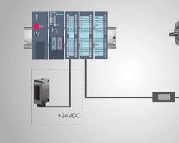Opens in a new windowIMG_257realpars.com](https://realpars.com/what-is-a-relay-system/)

motor control system using a relay switch

The control system consists of the following components:

* **Power supply:** Provides power to the motor and the relay switch.
* **Motor starter:** A contactor or other device that is used to switch on and off the high-power current required to start and operate the motor.
* **Relay switch:** A switch that is used to control the motor starter.
* **Control signals:** Signals that are used to turn the motor on and off, and to provide overload protection.

**Operation**

1. When a control signal is applied to the relay switch, it energizes the relay coil.
2. The energized relay coil creates a magnetic field that attracts and closes the relay contacts.
3. When the relay contacts are closed, they complete the circuit to the motor starter.
4. The energized motor starter then switches on the high-power current to the motor.
5. The motor then starts to operate.

When the control signal is removed from the relay switch, the relay coil de-energizes and the relay contacts open. This breaks the circuit to the motor starter, which then switches off the high-power current to the motor. The motor then stops operating.